ADDENDUM ONE
SHAREFILE LINK CORRECTIONS

Date: July 14, 2020

To: All Bidders

From: Dianna Gilliland/Connie Heinrichs, Buyers
                - Nebraska State Purchasing Bureau

RE: Addendum for RFP Number 6322 Z1 to be opened August 20, 2020 at 2:00:00 p.m. Central

The ShareFile links have been corrected as follows:

- Use the following link to electronically submit written questions:

https://nebraska.sharefile.com/r-r9462d4192c84e43a

- Use the following link to electronically submit proposals:

https://nebraska.sharefile.com/r-rce710b676fa481aa

- For each link above, the landing page will ask for the following information:

Entering the information below will provide an email confirmation of the upload for the bidder and the State.

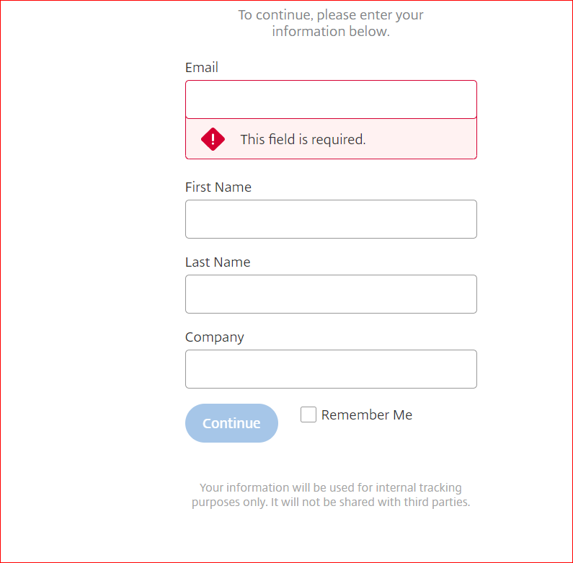

This addendum will become part of the proposal and should be acknowledged with the Request for Proposal response.

